**Histopathological study of the possible protective effect of Thymoquinone on liver of albino rats treated with cyclophosphamide**

Naglaa A.S. Sarg1, Samia M. Manawy1 and Asmaa Y.A. Hussein2

1Departments of Anatomy and Embryology, Faculty of Medicine, Benha University, Benha, Egypt

2Forensic Medicine and Clinical Toxicology, Faculty of Medicine, Benha University, Benha, Egypt

[drsamiamanawy@yahoo.com](mailto:drsamiamanawy@yahoo.com)

**Abstract: Background:** Cyclophosphamide (CP) is an oxazaphosphorine- alkylating agent widely used in the treatment of various neoplastic diseases and disorders associated with altered immunity. The optimal clinical usefulness of CP is severely limited by a high incidence of multiple organ toxicity. Many studies suggest that CP through its acrolein radical causes reactive oxygen species (ROS). Thymoquinone (TQ), the main constituent of the volatile oil from Negella sativa seeds. It is reported to possess strong antioxidant properties. **Aim of the work:** This research evaluates the possible protective effect of Thymoquinone on CP-induced liver toxicity in albino rats model. **Material and Methods:** Thirty albino rats were divided into three groups each one contains ten rats. **Group I (Control group**): The rats were received normal saline intraperitoneally. **Group II:** Each rat received 150 mg/kg cyclophosphamide (CP) as a single dose intraperitoneally. **Group III:** The rats pretreated with Thymoquinone (TQ) with a dose of 10mg/kg/day intraperitoneal for 7 days before the administration of 150 mg/kg CP a single dose intraperitoneally one week after the last dose. In each group, animals were sacrificed and the liver was identified and dissected out and prepared for histological examination after staining the tissues by Hematoxylin and eosin (H x & E) and Masson's trichrome. Also an Immunohistochemical study was done to detect α-smooth muscle actins (α –SMA). The mean area percentage of (α –SMA) expression was quantified in five images from five non-overlapping fields of each rat. The data were collected from the experiment, recorded and analyzed using IBM SPSS Statistics software. Electromicroscopic examinations**:** Semi-thin sections approximately 1 μm thickness were cut Sections were stained with toluidine blue. Ultrathin (below 100 nm) sections were collected on copper grids, stained with uranyl acetate and Reynold’s solution (sodium citrate and lead nitrate), then examined with transmission electron microscope (Philips 201C by Netherland) and photographed. **Results:** The liver sections of rats received cyclophosphamide (CP), showed loss of architecture of liver, dilated central vein and dilated sinusoids , with cellular infiltration around the central vein and in the portal area . The density of hepatocytes reduced with lacking acidophilic cytoplasm and the cells were vacuolated. Inflammatory cells were scattered in the hepatic parenchyma . There were proliferation of bile duct.

Marked increase of the collagen fibers deposition around the central vein and in portal areadetected by masson trichrome stain. On examination of liver section treated by TQ prior to CP, there were improvement of the liver tissue. The hepatic cells were normally arranged around the sinusoids, some cells were binucleated and acidophilic. Some sinusoids were dilated and less collagen fibers deposition around central vein than in group II. **Immunohistchemical stain (α-SMA stain:** Area % of α-SMA immuno- reactivity was highly significant increased in group II as compared to groups I & III (P<0.01). **Ultrastructure results:** The liver of rats from group (II) which received CP showed hepatocyte with nearly irregular nucleus, massive infiltration with lipid droplet, cytoplasmic vacuolation, dilated RER, rarified cytoplasm, dilated bile canaliculus with disrupted microvilli, swollen degenerated mitochondria with partial lysis of their cristae and collagen fibers. Liver from group III showed a normal hepatocyte with euchromatic nucleus. The cytoplasm contains many mitochondria, rough endoplasmic reticulum and rosettes shape of glycogen. **Conclusion:** Thymoquinone ameliorates cyclophosphamide-induced liver toxicity in albino rats liver.

[Naglaa A. S. Sarg, Samia M. Manawy and Asmaa Y. A. Hussei. **Histopathological study of the possible protective effect of Thymoquinone on liver of albino rats treated with cyclophosphamide.** *J Am Sci* 2018;14(12):117-126]. ISSN 1545-1003 (print); ISSN 2375-7264 (online). <http://www.jofamericanscience.org>. 13. doi:[10.7537/marsjas141218.13](http://www.dx.doi.org/10.7537/marsjas141218.13).

**Keywords:** Cyclophosphamid, Thymoquinone**,** liver- antioxidant

**1. Introduction**

Cyclophosphamide is an oxazaphosphorine- alkylating agent widely used in the treatment of various neoplastic diseases and disorders associated with altered immunity. The main use of CPA is as a chemotherapy in management of breast cancer, non- Hodgkin's lymphoma, acute myeloid leukemia, chronic myelogenous leukemia and acute lymphoblastic leukemia **(Khan et al., 2014).**

Unfortunately, the optimal clinical usefulness of CP is severely limited by a high incidence of multiple organ toxicity. To reach therapeutic effects of (CP)**,** this requires metabolic activation by the hepatic microsomal cytochrome P450 oxidase system (**Huttunen et al., 2011)**. This metabolic changes lead to the formation of two active cytotoxic metabolites which are phosphoramide mustard and acrolein. Phosphoramide mustard has antineoplastic activity, but acrolein is a highly reactive, has a short biological half-life and is responsible for CP toxic effects as cell death and apoptosis. **(Kern and Kehrer 2002).**

Many studies suggest that CP through its acrolein radical causes reactive oxygen species (ROS) like superoxide anion, hydroxyl radical, and hydrogen peroxide (H2O2) and leads to depression of the antioxidant defense mechanisms in organs as liver **( Stankiewicz et al., 2002)**.

So according to the changes in the cells induced by CP, it is essential to find a compound can protect the healthy cells against the toxic effects of CP metabolites as acrolein (**Bhattacharya et al.,2003).**

Natural herbal substances are studied for their ability to protect cells from damages. Recently the use of these substances as a protective in problems and diseases related to oxidative stress has great interest as they have the ability to protect the tissues and organs against oxidative stress **(Nabavi et al., 2012)**.

Black cumin (*Nigella sativa* L.) is a member of ranunculus family with white or light blue flowers that turn black when exposed to air. The main compounds of the aqueous extract of this plant are thymoquinone, dithymoquinone, thymohydroquinone, and thymol **(Razavi and Hosseinzadeh 2014 ).**

Thymoquinone (TQ), the main constituent of the volatile oil from Negella sativa seeds, is reported to possess strong antioxidant properties as it can remove superoxide, hydroxyl radical and singlet molecular oxygen **(Khan et al., 2005).**

It has many pharmacological activities as analgesic, anti inflammatory and antimicrobial effects against different species of bacteria. **(Ali and Blunden 2003)**. It also reported antitumor activities against cancer cells including colon, ovarian, lung and leukemia **(Kaefer and Milner2008).**

This study has been done to investigate the histological and ultrastructural toxic effects of CP on liver and to investigate the role of TQ in ameliorating the toxic effects of CP on liver.

**2. Materials and methods:**

**I-Materials**

**A-Animals:**

Adult male albino rats, three months age weighting 150±10 g were purchased from the Animal House of the Faculty of Veterinary Medicine, Benha University, Egypt. Animals were kept in plastic cages (each contained six animals) in the animal house for two weeks before the experimental work for accommodation. Animals were kept at 25 ± 2C° humidity of 50-60% and on 12h light/ 12h dark cycle. They received a standard diet composed of 50% barley, 20% yellow corn, 20% dry milk, 10% different vegetables and tap water. The study and all procedures were approved by the Animal Care and Bioethics Committee, Banha University, Egypt.

**B- Drugs:**

1. **cyclophosphamide**

It was obtained from( Sigma – Aldrich Company) as 1 gram vial (dry powder), the required dose for each rat weighed with the drug being dissolved in 0.9% saline the dose of cyclophosphamide was given as 150mg/kg/day. This dose had been reported to induce hepatotoxicity in rats without lethality ***(*Nese et *al*.*, 2014)*.**

**2-Thymoquinone**

Thymoquinone was purchased from (Sigma – Aldrich Company) and freshly dissolved in physiologic saline on the same day of each using the dose was given as 10mg/kg /day ***(*Osama *2013)*.**

**Experimental design:**

Animals were divided into three groups:

Group I (Control group): Animals of this group (10 rats) were served as control group and were given standard diet and tap water. Rats were received normal saline intraperitoneally.

Group II (Cyclophosphamid group): Animals of this group (10 rats). Each rat received a single dose of cyclophosphamide (CP) 150 mg/kg intraperitoneally.

Group III (CP and TQ group): Animals of this group (10 rats) received Thymoquinone (TQ) at a dose of 10mg/kg/day intraperitoneal for 7 days before the administration of a single intraperitoneal dose of 150 mg/kg CP.

**II-Methods:**

**1- Sample Preparation:**

One week after the last dose in each group, animals were sacrificed by cervical dislocation. the abdomen opened through a midline incision with the help of scalpel, the liver was identified and dissected out. The tissues were fixed in modified Bouin’s solution (0.2% picric acid 2% (v/v) formaldehyde in PBS) and then transferred to 70% alcohol for histological examination.

**2-Histopathological studies:**

The tissues stored were processed by dehydration in 90% alcohol, absolute alcohol and finally dipped in xylol. The liver was embedded in paraffin wax and blocks were prepared and labeled. 5µm thickness sections were cut using rotatory microtome. The sections were fixed on slides and stained using Haematoxylin and Eosin **(Bancroft and Gamble2008)**. and Masson's trichrome (MT) **(Leong 1996)**. Stained sections were studied and photographed.

**3-Immunohistochemical studies:**

**Immunoperoxidase staining for** α-SM (α-SMA ) actin and desmin was done on formalin-fixed and paraffin embedded tissues. Sections were pretreated with H202/ methanol and subsequently with 0.1 mol/l periodic acid, 0.005 mol/A NaBH4, and normal horse serum. They were incubated overnight at 40C with anti-aSM-1 or D33 at the dilutions of 1:500 and 1:50, respectively. The first incubation was followed by ABC-P staining according to the manufacturers' instructions. The peroxidase activity was revealed with 30% 3,3'diaminobenzidine (Serva, Heidelberg, FRG) in PBS containing 0.015% H202. Slides were counterstained weakly with Mayer's hematoxylin, dehydrated, and mounted in Eukitt. Controls were performed using a rabbit or mouse IgG instead of the primary antibody ( **Schmitt-Graff et al.*,* 1991)**.

**4-Morphometric study:**

The mean area percentage of α-SMA immuno-expression was quantified in five images from five non-overlapping fields of each rat using Image-Pro Plus program version 6.0 (Media Cybernetics Inc., Bethesda, Maryland, USA).

**Statistical analysis**

All the data collected from the experiment was recorded and analyzed using IBM SPSS Statistics software for Windows, Version 19 (IBM Corp., Armonk, NY, USA). One-way analysis of variance (ANOVA) with Post Hoc LSD test was used to compare differences among the groups. In each test, the data was expressed as the mean (M) value, standard deviation (SD) and differences were considered to be highly significant at P≤ 0.01, significant at P≤ 0.05 and non-significant at P>0.05.

**5- Electromicroscopic examinations:**

Samples were collected from the liver, were fixed in 3% glutaraldehyde and washed in 0.1 M sodium cacodylate buffer pH 7.4, post-fixed by 1% osmium tetraoxide and washed in buffer, and dehydrated in increasing concentrations of alcohol. The tissues were washed with propylene oxide and embedded in epoxy-resin embedding medium. Semi-thin sections approximately 1 μm thickness were cut with a glass knife on Leica ultracut (UCT) ultramicrotome. Sections were stained with toluidine blue. Ultrathin (below 100 nm) sections were collected on copper grids, stained with uranyl acetate and Reynold’s solution (sodium citrate and lead nitrate), and examined with transmission electron microscope (Philips 201C by Netherland) and photographed.

**3. Results**

**Histolopathological results**

**1- Heamatoxylin & eosin stain:**

The examination of control liver tissues showed normal hepatic architecture. Each hepatic lobule consists of a central vein surrounded by anastomosing radially distributing hepatic cells (hepatocytes). The hepatocytes are polygonal in shape with well defined boundaries. Their cytoplasm was acidophilic. The majority of cells had a single rounded, vesicular, central nucleus. Some cells were binucleated. The hepatic sinusoids were seen as narrow spaces in between adjacent plates. (fig. 1).

The liver sections of rats received cyclophosphamide (CP), showed loss of hepatic architecture with dilated central vein and sinusoids, there were inflammatory cellular infiltration around the central vein and in the portal area. There were proliferation of bile duct. The density of hepatocytes reduced with lacking acidophilic and the cells were vacuolated with pyknotic nuclei in some cells . Lymphocytes and inflammatory cells were scattered in the hepatic parenchyma and formed foci in some area between the hepatocytes known as focal hepatitis. (figs. 2&3).

On examination of liver section treated by TQ prior to CP, there were improvement of the liver tissue. The hepatic cells were normally arranged around the sinusoids, some cells were binucleated and acidophilic. Some sinusoids were dilated (fig. 4).

**Masson trichrome stain:**

On examination of control liver group (I), it showed a little amount of collagen fibers around the central vein. (fig.5).

In Group II, liver sections from group (II) which received CP showed marked increase of the collagen fibers deposition around the central vein and in the portal area when compared with the control (fig. 6).

In group (III) which are treated by TQ before CP showed few collagen fibers deposition than that in group (II) (fig. 7).

**Immunohistchemical stain (α-SMA stain):**

Control group showed only minimal α-SMA positive cells around the central vein .(fig. 8).

On examination of liver of rats received CP showed massive positive reaction for α-SMA observed in-between the hepatocytes (fig 9).

While the livers of rats treated by TQ and CP showed few positive reaction for α-SMA (fig. 10).

The mean area % of α-SMA immuno-expression for all groups was represented in (Table 1) and (Histogram 1). There was insignificant increase in α-SMA immuno-expression (P>0.05) in group III as compared with control group. But area % of α-SMA immuno- reactivity was highly significant increased in group II as compared to groups I & III (P<0.01).

**Ultrastructure results:**

Transmission electron micrograph of liver of control group showed normal hepatocyte with euchromatic nucleus. The cytoplasm contained many mitochondria, rough endoplasmic reticulum and rosettes shape of glycogen (figs. 11 & 12 ).

The liver of group (II) showed hepatocyte with nearly irregular nucleus , massive infilteration with lipid droplet which compress the nucleus , cytoplasmic vacuolation, dilated RER, rarified cytoplasm, dilated bile canaliculus with disrupted microvilli, swollen degenerated mitochondria with partial lysis of their cristae and collagen fibers. (figs. 13,14 & 15).

liver from group (III) ) showed a normal hepatocyte with euchromatic nucleus. The cytoplasm contains many mitochondria, rough endoplasmic reticulum and rosettes shape of glycogen. The cell is more or less normal, with normal nucleus, mitochondria and bile duct (figs. 16 & 17).

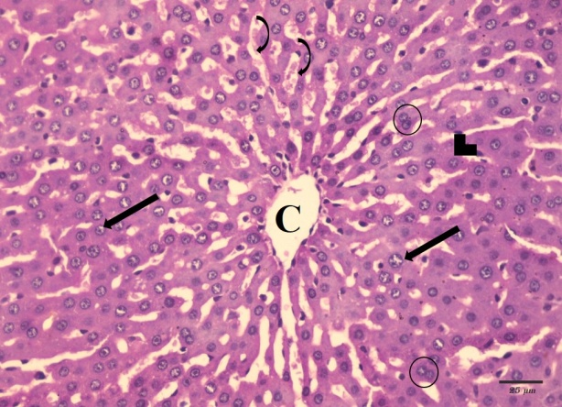

**Fig. (1):** A photomicrograph of a section in the liver from control group showing normal architecture of hepatic lobe , hepatocytes radiating from the central vein (C) with acidophilic cytoplasm (arrow head) and central rounded vesicular nuclei (arrow). Some of the cells appear bi-nucleated (circle). The sinusoids are normal (curved arrow). (H&E x400)

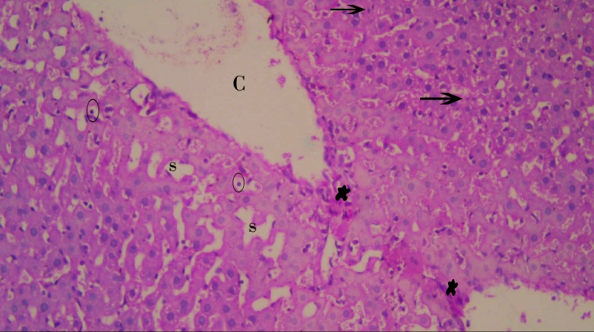

**Fig. (2):** A photomicrograph of a section in the liver from rat received CP(group II), showing loss of normal architecture of liver . Dilatation of central vein (C), with infiltration with inflammatory cells (asteric) around it . There are foci of inflammatory cells in between hepatocytes (arrows).The hepatocytes show decrease of acidophilic cytoplasm , vacuolations and pyknotic nuclei (circle). Notice : dilatation of sinusoids (s) . (H&E x400).

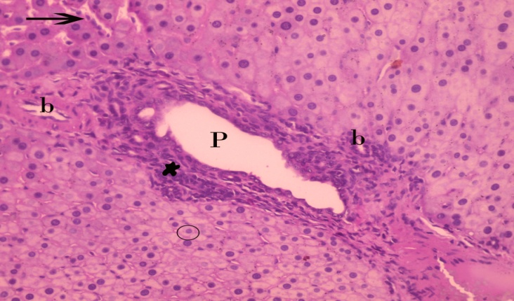

**(Fig. 3) :**A photomicrograph of a section in the liver from CP- received group( group II), showing dilated ,thickened portal vein (p), with infiltration with inflammatory cells (asteric ) . Proliferation of bile duct (b) can be seen .The destructed cells show decrease of acidophilic cytoplasm of some hepatocyte (circle) with pyknotic nuclei . Notice : inflammatory cells in-between hepatocytes (arrow). (H&E x400)

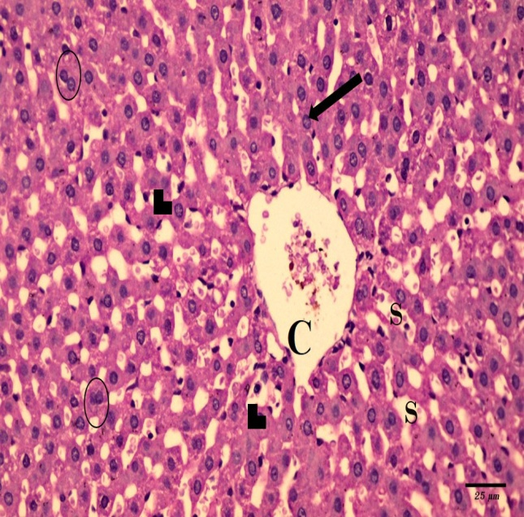

**Fig. (4):** A photomicrograph of a section in the liver from group III treated by TQ & CP showing more or less normal architecture of hepatocytes radiating from the central vein (C) with acidophilic cytoplasm (arrow head) and central rounded vesicular nuclei (arrow). Some of the cells appear bi-nucleated (circle). Notice: mild dilatation of some sinusoids (s) . (H&E x400)

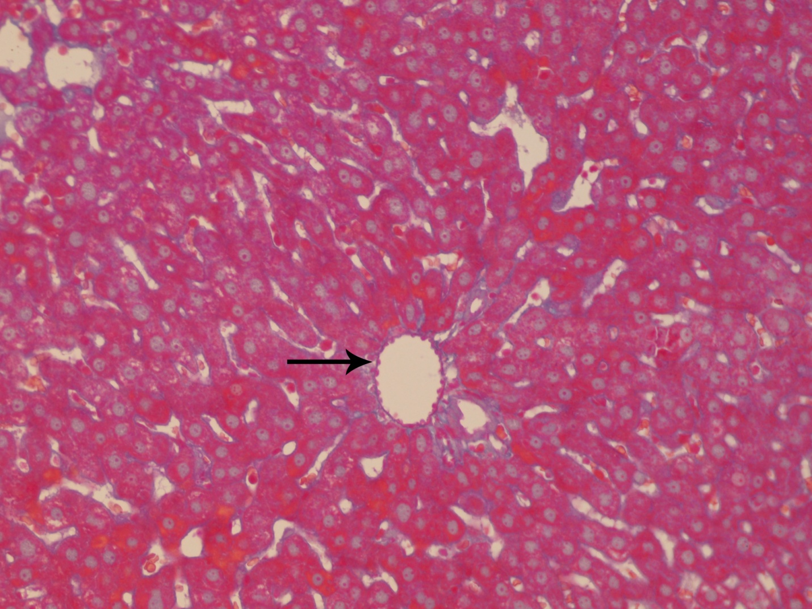

**Fig. (5):** A photomicrograph of a section of the liver from the control group showing minimal collagen fibers (arrow). (Masson trichrome x 400)

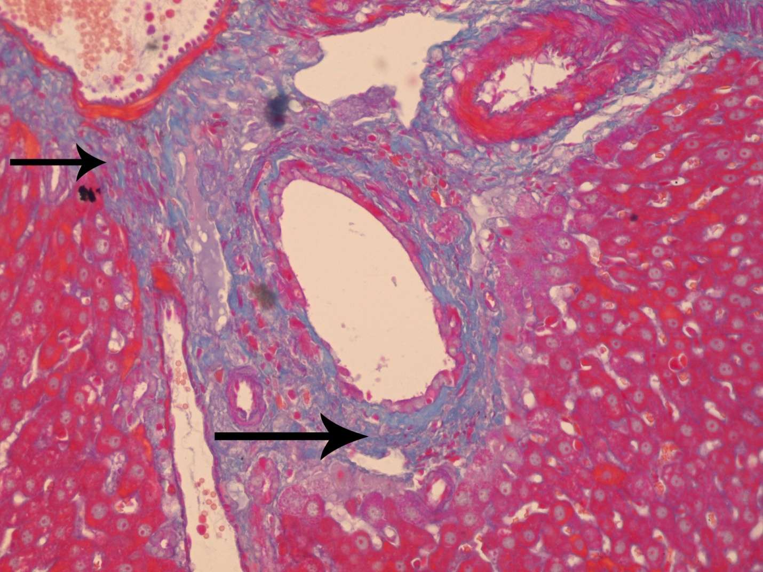

**Fig. (6):** Photomicrograph of a section in the liver from CP- received group showing massive infiltration with collagen fibers (arrows). (Masson trichrome x 400)

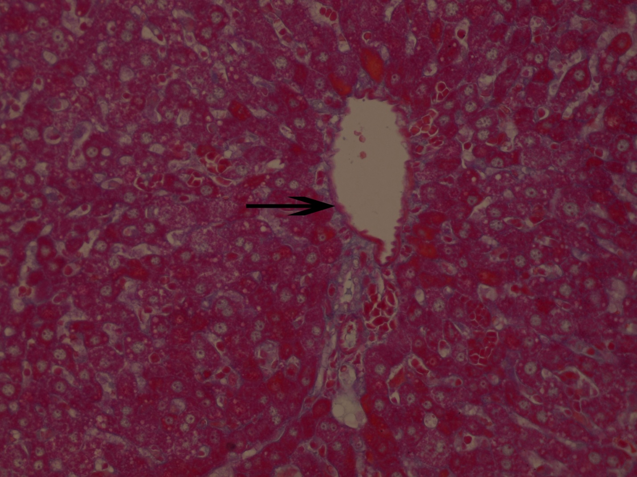

**Fig. (7):** A photomicrograph of a section in the liver from group III showing few collagen fibers (arrow). (Masson trichrome x 400)

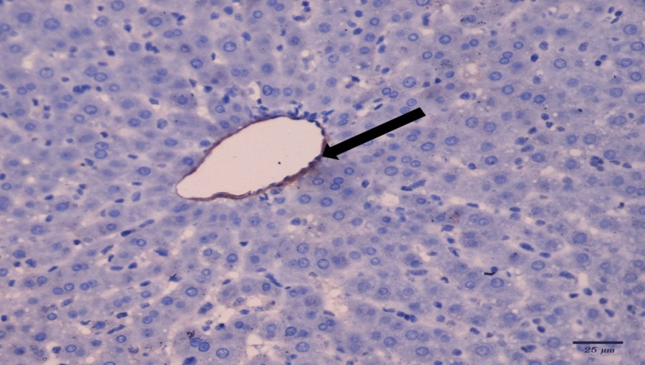

**(Fig. 8):** A photomicrograph of control group showing lack of positive reaction for immunostaining α-SMA in the liver. Only minimal α-SMA positive cells (arrow) . (α-SMA x 400)

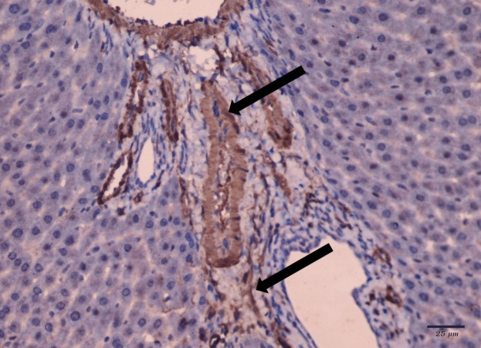

**Fig. (9):** A photomicrograph of CP- received group showing strong positive reaction for immunostaining α-SMA observed (arrows). (α-SMA x 400)

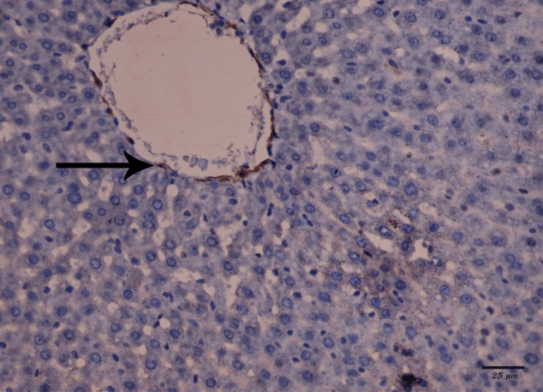

**Fig. (10):** A photomicrograph of TQ & CP-treated group showing few positive reaction for  immunostaining α-SMA (arrow). (α-SMA x 400)

Table (1): Showing mean values of area percent α-SMA immuno- reactivity± SD in the 3 groups

|  |  |  |  |  |  |
| --- | --- | --- | --- | --- | --- |
| P value | F test | Group III | Group II | Group I | Mean% ± SD |
| 0.001 | 27.27 | 1.09±0.576 | 8.46±2.3 | 0.771±0.453 | MA |
|  |  | With group II | With groups I & III | With group II | Significance ≤ 0.01 |



Histogram (1): Showing mean values of area percent α-SMA immuno- reactivity in the 3 groups

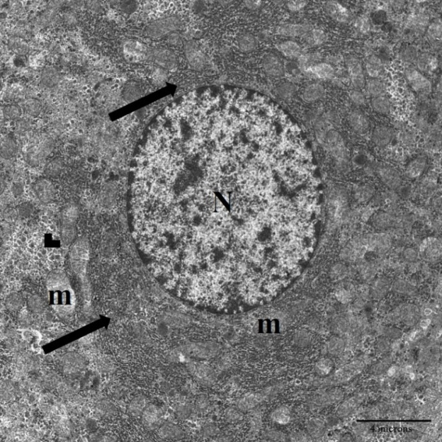

**Fig. (11):** Transmission electron micrograph of liver of control group showing a normal hepatocyte with euchromatic nucleus (N). The cytoplasm contains many mitochondria (m), rough endoplasmic reticulum (arrow) and rosettes shape of glycogen (arrow head). (x 8000)

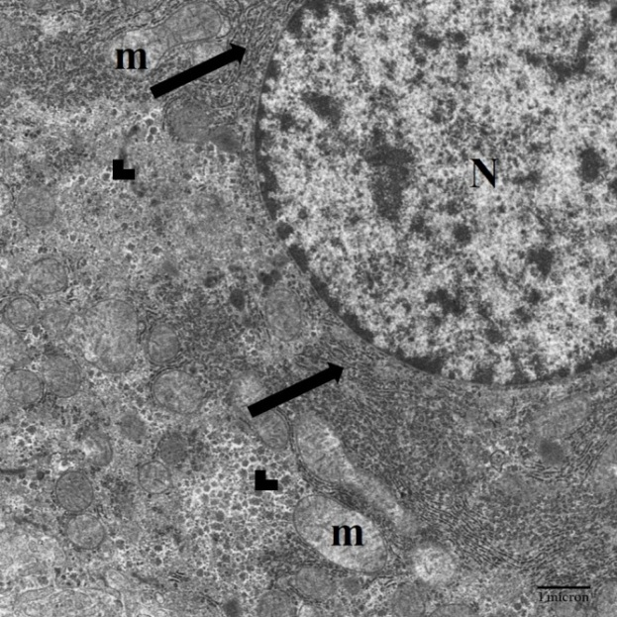

**Fig. (12):** Magnification of the previous figure showing a normal hepatocyte with euchromatic nucleus (N). The cytoplasm contains many mitochondria (m), rough endoplasmic reticulum (arrow) and rosettes shape of glycogen (arrow head). (x 17500)

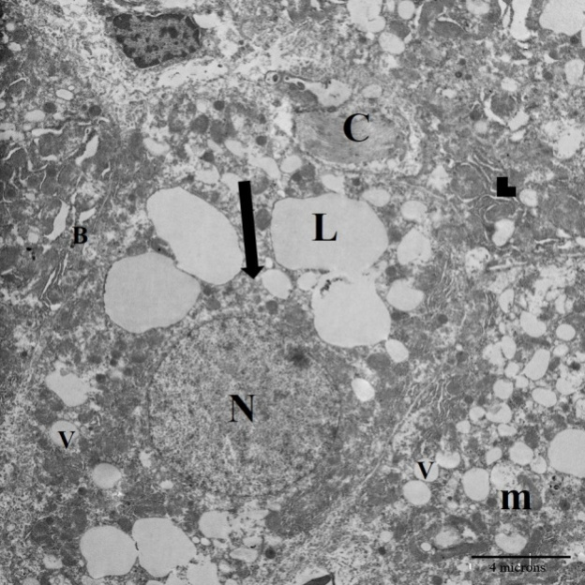

**Fig. (13):** Transmission electron micrograph of liver from group II (received CP ) showing hepatocyte with nearly compressed nucleus (N), massive infilteration with lipid droplet (L), cytoplasmic vacuolation (V), dilated RER (arrow head), rarified cytoplasm (arrow), disrupted bile canaliculus (B), swollen degenerated mitochondria (m), collagen fiber (C). (x 8000)

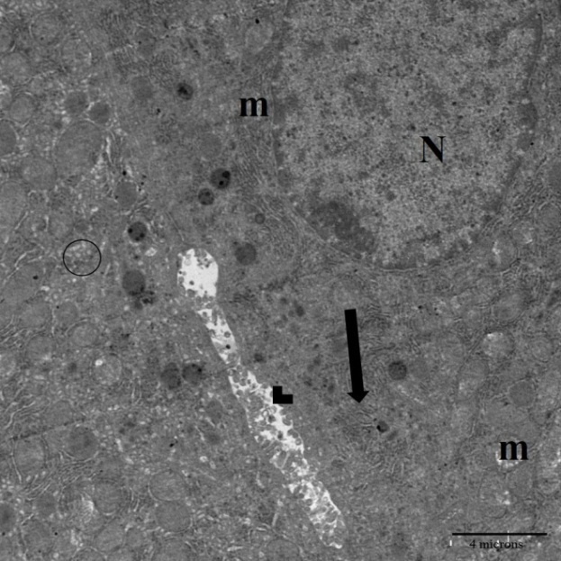

**Fig. (14)**: Transmission electron micrograph of liver from the group received CP, showing irregular nucleus (N). The cytoplasm contains mitochondria with partial lysis of their cristae (m), dilated bile canaliculus with disrupted microvilli (arrow head) , dilated RER (arrow) and SER (circle). (x 8000)

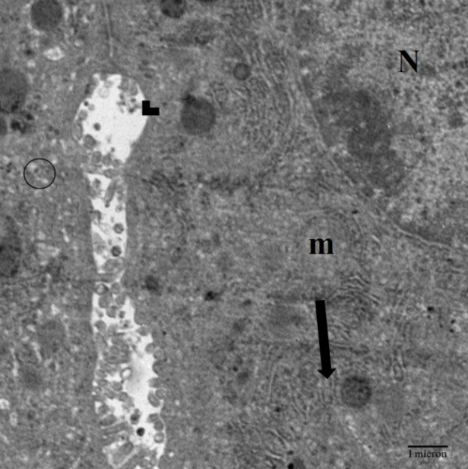

**Fig. (15):** Magnification of the previous figureshowing irregular nucleus (N). The cytoplasm contains mitochondria with partial lysis of their cristia (m), RER (arrow), dilated bile canaliculus with disrupted microvilli (arrow head) between desmosomes (circle). (x 17500)

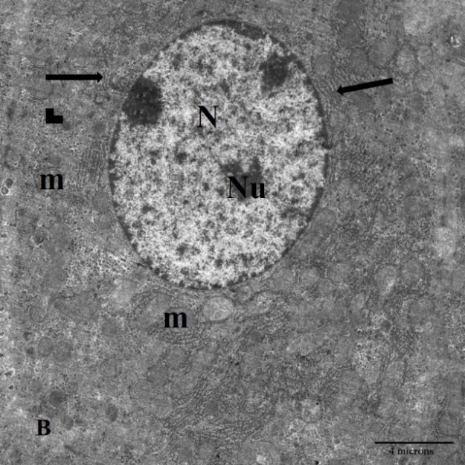

**Fig. (16)** Transmission electron micrograph of liver treated by TQ & CP group, showing a more or less normal hepatocyte with euchromatic nucleus (N). The cytoplasm contains many mitochondria (m), rough endoplasmic reticulum (arrow) and rosettes shape of glycogen (arrow head) ,bile canaliculus (B). (x 8000)

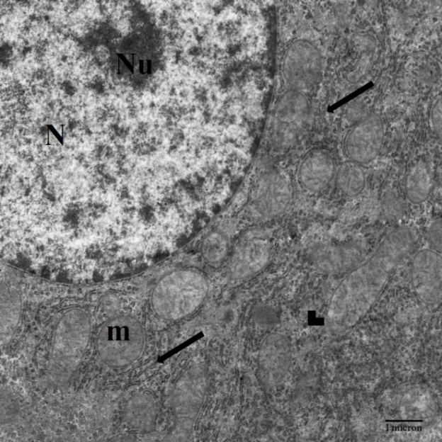

**Fig. (17):** Magnification of the previous figure showing a more or less normal hepatocyte with euchromatic nucleus (N), nucleolus (Nu). The cytoplasm contains many mitochondria (m), rough endoplasmic reticulum (arrow) and rosettes shape of glycogen (arrow head). (x 17500)

**4. Discussion**

Cyclophosphamide is considered the commonest chemotherapeutic agent used in the treatment of several human cancers, but known to induce marked oxidative stress in the liver via causing severe cellular damage accompanied by lipid peroxidation and changes in cellular nucleic acids. **(Zarei et al., 2013)**

In the current study CP administration caused marked deterioration of the histopathological architecture of the liver tissue when compared to normal control group. It was proved that the high dose of CP (150mg single injection) led to damage of liver tissues and which appeared in low density of hepatocytes, vacuolations, scattered area of inflammatory cell aggregates in between the hepatocytes known as focal hepatitis, dilated central veins. periportal inflammation, congested portal veins and proliferation of the bile ducts. these findings in line with comparable studies **(El Nagar,2015)**.

The proliferation of the bile ducts (ductular reaction) of the liver in response to various liver injuries is characterized by an increase in the number of intrahepatic bile ducts. **(LeSag et al, 2001)**. Proliferation of bile ducts and dilatation of bile canaliculi were attributed by to a response of cholestasis which was caused by continuous increase of the intrahepatic duct pressure causing dilatation of bile ducts in large portal areas ***Sarah et al., (2005)***.

Also this was confirmed by ***Sanjiv, (2002),*** who suggested that, this phenomenon in ductular structures is partially caused by active proliferation of ductular cells.

**Shokrzadeh et al.*,* 2014** found that the metabolites of CPA causing injury of the endothelial lining of the blood vessels and this in agreement with The histological findings in this study such as central vein engorgement and dilatation, destruction of some blood vessels and hemorrhage between hepatocyte and subsequently hepatocyte degeneration.

These pathological changes may be associated with the ability of CPA to induce the generation of free radical and to deplete the antioxidant defense system .Studies have shown that oxygen-derived free radical plays an important role in the pathogenesis of injury to various tissues **(Santra et al.*, 2000*).**

In the present study α-SMA of CP- treated group showing strong positive reaction around the central vein; in portal area and in -between the hepatocytes with a massive infiltration with inflammatory cells. This findings in agreement with **( Schmitt-Graff et al.*,* 1991)** who stated that a large variety of hepatic pathologic conditions is accompanied by an increase in expression of α -SM actin. Most of these pathologic settings are characterized by fibrosis.

Appearance of expression of a-SM actin is more prominent in active stages of fibrosis and cirrhosis accompanied by cell death than in advanced or inactive stages. **( Carpino et al.*,* 2005).**

In the present study transmission electron micrograph of liver of CP treated group showing irregular nucleus. Rarified cytoplasm with vacuolation. The cytoplasm contains swollen mitochondria with partial lysis of their cristia. Dilated bile canaliculus with disrupted microvilli. Also there is massive infilteration with lipid droplet dilated RER and increased collagen fiber.

**Mariola et al.*,* 2002** stated that CP has been proved to induce significant alterations in the activity of NADH and NADPH2, likely to be responsible for the ultrastructural changes within mitochondria. However, we observed features of mitochondrial damage with disruption of mitochondrial membranes. They assumed that an increase in MDA level in liver homogenates may be a biochemical evidence of these changes.

The beneficial effect was attributed to TQ having strong antioxidant, anti-inflammatory antifibrotic, as well as anti carcinogenic effects **(Aysun et al.*,* 2018)**

Pre treatment of thymoquinone leads to regaining normal architecture of hepatocytes with normal central nuclei. Regeneration of hepatocytes can be observed by the presence of binucleate cells and minimal collagen fibers deposition around central vein. but of mild sinusoidal congestion still present. This finding in agree with study of **(Alenzi et al., 2010)** and the study of **Laskar et al.*,* 2016** who study the effect of TQ on hyperbilirubinemia and liver toxicity caused by CP.

Treatment regimen with potential antioxidant agents could be an approach to ameliorate chemotherapeutic toxicity **(Jalali et al., 2012)**

Damaged hepatocytes, Kupffer and endothelial cells can be counted among the stimuli that induce hepatic stellate cells (HSC) activation and scar tissue may appear with hepatic fibrosis **( Urtasum and Nieto 2007)**

Free radicals and lipid peroxides also play a role in the prognosis of hepatic damage and in liver fibrosis **(Kanter.*,* 2003)**

TQ had the antioxidant effects and a free radical scavenging activity and reduced oxidative stress conditions in the erythrocyte and liver tissue in a model of experimental liver fibrosis of rats **(Edibe et al.*,* 2014)**

**Abdelghany et al.** **2016** attributed the TQ-induced inhibition of the progression of fibrosis in CCI4 toxicity models to the modulation of several fibrosis-related inflammatory mediators such as IL-6, IL-6R, IL-22, IL-22RA1+2, IL-10RA and IL-10RB.

**Conclusions:**

The findings of this study showed that administration of thymoquinone, as a potent antioxidant, could have protective properties against the destructive effects of cychlophosphamid in the liver of rat. And consequently improve the structure of liver.

**References**

**1.**  Abdelghany, A.H.; BaSalamah, M.A.; Idris, S.; Ahmad, J.; Refaat, B. The fibrolytic potentials of vitamin D and thymoquinone remedial therapies: Insights from liver fibrosis established by CCl4 in rats. J. Transl. Med. 2016, 14, 281

**2.**  [Alenzi FQ](https://www.ncbi.nlm.nih.gov/pubmed/?term=Alenzi%20FQ%5BAuthor%5D&cauthor=true&cauthor_uid=20373678)1, [El-BolkinyYel-S](https://www.ncbi.nlm.nih.gov/pubmed/?term=El-Bolkiny%20Yel-S%5BAuthor%5D&cauthor=true&cauthor_uid=20373678), [Salem ML](https://www.ncbi.nlm.nih.gov/pubmed/?term=Salem%20ML%5BAuthor%5D&cauthor=true&cauthor_uid=20373678). Protective effects of Nigella sativa oil and thymoquinone against toxicity induced by the anticancer drug cyclophosphamide.[Br J Biomed Sci.](https://www.ncbi.nlm.nih.gov/pubmed/20373678) 2010;67(1):20-8.

**3.** Ali, B.H., Blunden, G. Pharmacological and toxicological properties of Nigella sativa. Phytother. Res. ., 2003; 17, 299–305.

**4.**  Aysun Tekbas Jutta Huebner , UtzSettmacher and UtaDahmen Plants and Surgery: The Protective Effects of Thymoquinone on Hepatic Injury—A Systematic Review of In Vivo Studies International Journal o fMolecular Sciences2018.;19 ( 4):1085•

**5.**  Bancroft J. D. and Gamble M. (2008): Theory and practice of histological techniques. 6th ed. Churchill Livingstone. London, New York & Sydney, PP. 121-132.

**6.**  Bhattacharya, R. A. Lawrence, A. Krishnan, K. Zaman, D. Sun, and G. Fernandes, “Effect of dietary n-3 and n-6 oils with and without food restriction on activity of antioxidant enzymes and lipid peroxidation in livers of cyclophosphamide treated autoimmune-prone NZB/W female mice,” Journal of the American College of Nutrition, 2003 vol. 22, no. 5, pp. 388–399.

**7.** [Carpino G](https://www.ncbi.nlm.nih.gov/pubmed/?term=Carpino%20G%5BAuthor%5D&cauthor=true&cauthor_uid=15843085)1, [Morini S](https://www.ncbi.nlm.nih.gov/pubmed/?term=Morini%20S%5BAuthor%5D&cauthor=true&cauthor_uid=15843085), [Ginanni Corradini S](https://www.ncbi.nlm.nih.gov/pubmed/?term=Ginanni%20Corradini%20S%5BAuthor%5D&cauthor=true&cauthor_uid=15843085), [Franchitto A](https://www.ncbi.nlm.nih.gov/pubmed/?term=Franchitto%20A%5BAuthor%5D&cauthor=true&cauthor_uid=15843085), [Merli M](https://www.ncbi.nlm.nih.gov/pubmed/?term=Merli%20M%5BAuthor%5D&cauthor=true&cauthor_uid=15843085), [Siciliano M](https://www.ncbi.nlm.nih.gov/pubmed/?term=Siciliano%20M%5BAuthor%5D&cauthor=true&cauthor_uid=15843085), [Gentili F](https://www.ncbi.nlm.nih.gov/pubmed/?term=Gentili%20F%5BAuthor%5D&cauthor=true&cauthor_uid=15843085), [Onetti Muda A](https://www.ncbi.nlm.nih.gov/pubmed/?term=Onetti%20Muda%20A%5BAuthor%5D&cauthor=true&cauthor_uid=15843085), [Berloco P](https://www.ncbi.nlm.nih.gov/pubmed/?term=Berloco%20P%5BAuthor%5D&cauthor=true&cauthor_uid=15843085), [Rossi M](https://www.ncbi.nlm.nih.gov/pubmed/?term=Rossi%20M%5BAuthor%5D&cauthor=true&cauthor_uid=15843085), [Attili AF](https://www.ncbi.nlm.nih.gov/pubmed/?term=Attili%20AF%5BAuthor%5D&cauthor=true&cauthor_uid=15843085), [Gaudio E](https://www.ncbi.nlm.nih.gov/pubmed/?term=Gaudio%20E%5BAuthor%5D&cauthor=true&cauthor_uid=15843085). Alpha-SMA expression in hepatic stellate cells and quantitative analysis of hepatic fibrosis in cirrhosis and in recurrent chronic hepatitis after liver transplantation. [Dig Liver Dis.](https://www.ncbi.nlm.nih.gov/pubmed/15843085) 2005 May;37(5):349-56.

**8.**  Edibe Sariciceka, Mehmet Tarakcioglub, Vahap Saricicekc, Murat TanerGulsend, Metin Karakoke, Yasemin Baltacif .Effect of Nigella sativa on experimental liver fibrosis. Biomedical Research2014; 25 (1): 32-38

**9.** Huttunen, K.M.; Raunio, H. and Rautio, J. Prodrugs--from serendipity to rational design. Pharmacological Reviews , (2011); 63 (3): 750–71.

**10.** Jalali AS, Hasanzadeh S, Malekinejad H.; Achillea millefolium inflorescence aqueous extract ameliorates cyclophosphamide-induced toxicity in rat testis: Stereological evidences. Chin J Nat Med, 2012;10:247–54.

**11.**  Kaefer C. M and Milner J. A., “The role of herbs and spices in cancer prevention,” Journal of Nutritional Biochemistry, , 2008 ; vol. 19, no. 6, pp. 347–361

**12.**  Kanter M. Effects of Nigella sativa L. and Urticadiocica L. on lipid peroxidation, antioxidant enzyme systems and some liver enzymes in CCl4 –treated rats. JVet Med. 2003;50:264–8.

**13.**  Kern JC and Kehrer JP. Acrolein-induced cell death: a caspase-influenced decision between apoptosis and oncosis/necrosis. Chem Biol Interact 2002;139(1):79-95.

**14.**  Khan J, Shahdad S, Makhdoomi M,Hamid S, Bhat M, Jan Y. et.al. Effect of Cyclophoshamide on the microanatomy of liver of albino rats. Int J Res Med Sci. 2014;2:1466-9

**15.** Khan N, Sultana S: Inhibition of two stage renal carcinogenesis, oxidative damage and hyper proliferative response by Nigella sativa. Eur J Cancer Prev 2005, 14:159–168.

**16.**  [Laskar AA](https://www.ncbi.nlm.nih.gov/pubmed/?term=Laskar%20AA%5BAuthor%5D&cauthor=true&cauthor_uid=27265787), [Khan MA](https://www.ncbi.nlm.nih.gov/pubmed/?term=Khan%20MA%5BAuthor%5D&cauthor=true&cauthor_uid=27265787), [Rahmani AH](https://www.ncbi.nlm.nih.gov/pubmed/?term=Rahmani%20AH%5BAuthor%5D&cauthor=true&cauthor_uid=27265787), [Fatima S](https://www.ncbi.nlm.nih.gov/pubmed/?term=Fatima%20S%5BAuthor%5D&cauthor=true&cauthor_uid=27265787), [Younus H](https://www.ncbi.nlm.nih.gov/pubmed/?term=Younus%20H%5BAuthor%5D&cauthor=true&cauthor_uid=27265787) .Thymoquinone, an active constituent of Nigella sativa seeds, binds with bilirubin and protects mice from hyperbilirubinemia and cyclophosphamide-induced hepatotoxicity. [Biochimie.](https://www.ncbi.nlm.nih.gov/pubmed/27265787) 2016; Aug;127:205-13.

• **17.**  Leong, A. S.: Principles and practice of medical laboratory science. (1996) Volume 1: Basic Histotechnology. 1st ed., Philadelphia, Saunders Company.P. 171..

**18.**  Le Sage G, Glaser S, Alpini G: Regulation of cholangiocyte proliferation. Liver , 2001;21:73–80.

**19.**  Mariola Sulkowska, Elżbieta Skrzydlewska, Maria Sobaniec-Łotowska, Waldemar Famulski, Sławomir Terlikowski, Luiza Kańczuga- Koda, Joanna Reszeć And Irena Daniszewska : Effect Of Cyclophosphamide-Induced Generation Reactive Oxygen Forms On Ultrastructure Of The Liver And Lung Bull. Vet. Inst. Pulawy , 2002; 46, 239-246.

**20.**  Nabavi, S.M., Nabavi, S.F., Eslami, S., Moghaddam, A.H,: In vivo protective effects of quercetin against sodium fluoride-induced oxidative stress in the hepatic tissue. Food Chem., 2012; 132, 931–935.

**21.**  Nese Arzu Yener, Orhun Sinanoglu, Erdin Ilter, Aygen Celik, Gulbuz Sezgin, AhmetMidi, Ugur Deveci, and Fehime Aksungar: Effects of spirulina on cyclophosphamide-induced ovarian toxicity in rats: biochemical and histomorphometricevaluation of the ovary biochemistry Research International Volume 2013, Article ID 764262Accepted 10 April 2013.

**22.**  Osama Adnan Kensara Thymoquinone supplementation protects against gentamicin- induced nephrotoxicity in rats.Research Journal of medical sciences 2013; 7 (2):60-64.

**23.**  Razavi BM, Hosseinzadeh H. :A review of the effects of Nigella sativa L. and its constituent, thymoquinone, in metabolic syndrome. J Endocrinol Invest 2014;37:1031‑40.

**24.**  Sabry A. El-Naggar, Abeer A. Alm-Eldeen, Mousa O. Germoush, Kamal F. El-Boray& Hassan A. Elgebaly :Ameliorative effect of propolis against cyclophosphamide-induced toxicity in mice Pharmaceutical Biology, 2015 ; 53:2, 235-241.

**25.**  Sanjiv C. The liver book: A Comprehensive Guide to diagnosis, treatment and recovery. Atria. 2002; P. 743 – 754.

**26.** Santra A, Chowdhury A, Chaudhuri S, Das Gupta J, Banerjee PK, Mazumder DN :Oxidative stress in gastric mucosa in Helicobacter pylori infection. Indian J Gastroenterol. 2000;19:21–3.

**27.**  Sarah K., Milo F., Eliezer R. and Theodore :Hepatotoxicity of combined treatment with cisplatin and gentamicin in the guinea pig. Ultrastructural Pathology. (2005);. 29(2):129-137.

**28.** Schmitt A Graff ,Kruger S ,Bochard F ,Denkt H ; Modulation of Alpha Smooth Muscle Actin and Desmin Expression in Perisinusoidal Cells of Normal and Diseased Human Livers. American Joumal of Pathology, 1991; Vol. 138, No. 5, May

**29.**  Shokrzadeh M, Ahmadi A, Naghshvar F, Chabra A, Jafarine jhadM :Prophylactic Efficacy of Melatonin on Cyclophoshamide-Induced Liver toxicity. Biomed Res Int. 2014.

**30.**  Stankiewicz A, Skrzydlewska E and Makieła M :Effects of amifostine on liver oxidative stress caused by cyclophosphamide administration to rats. Drug Metab and Drug Inter 2002; 19 (2): 67–82.

**31.** Urtasun R, Nieto N. :Hepatic stellate cells and oxidative stress. Rev Esp Enferm Dig. 2007;99:223–30.

**32.**  Zarei M, Shivanandappa T.: Amelioration of cyclophosphamide-induced hepatotoxicity by the root extract of Decalepishamiltonii in mice. Food and chemical toxicology. 2013;57:179-84.